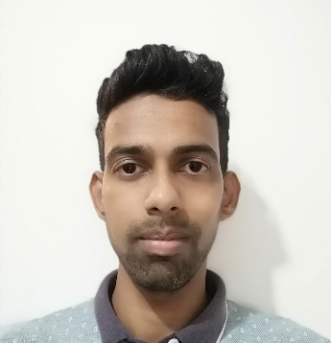
MR. JERRY SIQUEIRA

KHOBRA VADDO, CALANGUTE, BARDEZ, GOA, INDIA - 403516
CONTACT NO : +91 8698786368
E-MAIL : sequeirajerry@gmail.com
OBJECTIVES
To gain a good position in the Hospitality industry, where my knowledge and skill is utilized and growth is accomplished.
EDUCATIONAL QUALIFICATION
Secondary School Certificate from Lourdes Convent High School in the year 1999-2000.
ADDITIONAL QUALIFICATION
*Certificate course in Food and Beverage Production at Alcon Victor Institute in 2002.
* Completed STCW 2010 Courses in the year 2015.
WORK EXPERIENCE
* Worked for Cruise and Maritime Voyages on the ship “MV ASTORIA” as a 1st COOK from 13th February 2019 to 6th November 2019.
*Worked for Cruise and Maritime Voyages on the ship “MV ASTORIA” as a 1ST Cook from 22nd February 2018 to 31st October 2018.
*Worked for Cruise and Maritime Voyages on the Ship "MV ASTORIA" as a 2nd Cook from 27th February 2017 to 9th November 2017.
*Worked for Cruise and Maritime Voyages on “MV ASTORIA” as 2nd COOK from 1st March 2016 to 10th November 2016.
*Worked for Cruise and Maritime Voyages on “MV AZORES” as 3rd COOK from 9th January 2015 to 2nd October 2015.
*Worked for Cruise and Maritime Voyages on the ship "MV DISCOVERY" as a Coffee Man and 3rd Cook from 04th February 2014 to 6th October 2014.
*Worked for “AIDA CRUISES” as Galley Utility from January 2010 to June 2013.
*Worked for Victor Exotica Beach Resort as a Continental Commi II from December 2006 to March 2009.
*Worked for Victor Exotica Beach Resort as a Continental Commi III from November 2004 to December 2006.
*Worked for Ondas Do Mar Resort as an Assistant Pantry man from November 2003 to May 2004.
*Underwent Industrial Exposure Training in Food and Beverage Production from October 2002 to May 2003 at Victor Exotica Beach Resort.
AWARDS
Best Employee of the Month for July 2006 at Victor Exotica Beach Resort.
STRENGTHS
Desire to Learn and Excel.
Good team player.
Good Communication Skills.
PERSONAL DETAILS
Date of Birth : 07th October 1985
Nationality : Indian
Marital Status : Married
Height : 5ft 8in
Languages : Fluent in English, Hindi and Konkani.
Hobbies : Playing Table Tennis and Listening to Music
PASSPORT DETAILS
Passport No : P3869845
Date of Issue : 08th December 2016
Date of Expiry : 07th December 2026
Place of Issue : Panaji, Goa

