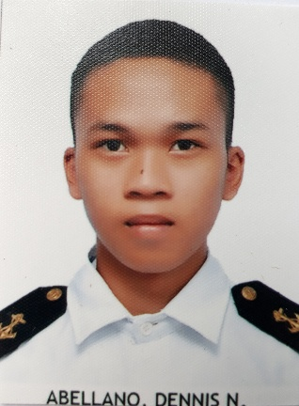
Zone #2, Buyoan, Legazpi City
dabellano64@gmail.com
09517715430 / 09663950188
SSS: 05-1385237-6
PAG-IBIG: 121200712354
PHILHEALTH: 1025-2819-5420

DENNIS N. ABELLANO
Objective
To inhance and utilize my abilities, knowledge and skill’s that I’ve learned and share it in the company / Organization and contribute in the most effective manner by being the key and effective team player. To obtain a position that would further enhance my knowledge and skills to become professionally competitive and capable with practical experiences for my personal and professional growth to be effective in your company.

DESIRE POSITION: O/S or DECK CADET

EDUCATION BACKGROUND
ELEMENTARY LEVEL
Buyoan Elementary School
Buyoan Legazpi city

SECONDARY LEVEL
Pag-asa National High School (PNHS)
Rawis Legazpi City

TERTIARY LEVEL
Mariners’ Polythecnic Colleges Foundation
Rawis Legazpi City

SEMINARS / TRAINING ATTENDED

Basic Swimming Lesson
MPCF (LC)
October 2015

BT (Basic Training)
MPCF (LC)
February 2018

Ship Security Awareness Training
For Seafarers With Designated
Security Duties (SDSD)
MPCF (LC)
February 2018

Consolidated Marpol 73/78, ANNEXES I-VI
ALLSTAR Maritime Training Center
June 2018

Crowd and Crisis Management For
Personnel Serving Onboard Domestic
RORO / Passenger / Cargo Passenger
Ships
ALLSTAR Maritime Training Center
June 2018

CGO NSTP ( Coast Guard Oriented National
Service Training Program
MPCF (LC)
2015-2016

AWARD RECEIVE
Proficiency In Seamanship
April 2018

LAND WORK EXPIRIENCE
Greenwich Ayala
Legazpi City
2017

SEA WORK EXPIRIENCE
COMPANY: Peñafrancia Shipping Corp.
SHIP NAME: LCT ST-888
GROSS TONNAGE: 518 TONS
POSITION: DECK CADET
DURATION : 1 Years and 3 days (369)
FROM: February 24, 2020
TO: February 27, 2020

SKILLS
- Computer Litterate
- Can work with minimal supervision
- Adaptive and highly responsive person and capable in working underpressure
- Passion for continues learning and personal growth
- Highly organize and dedicated with a positive attitude

PERSONAL DATA

DATE OF BIRTH: November 8, 1998
PLACE OF BIRTH: Buyoan Legazpi City
CITIZENSHIP: Filipino
CIVIL STATUS: Single
AGE: 22
GENDER: Male
HIEGHT: 5’5
WEIGHT: 60 kg.
RELIGION:Roman Catholic

CHARACTER REFFERENCE

Capt. William Eluzon
Seaman( CAPTAIN )

Jetro Naz
Engineer

James Palisa
Coast Guard

