SEAFARERS APPLICATION FORM
Position applied for __Chief Engineer______________
Date of availability ___10.03.2021______________
NAME: Andrei |  | SURNAME: Kovtun |  |  |  |  |  |  | PHOTO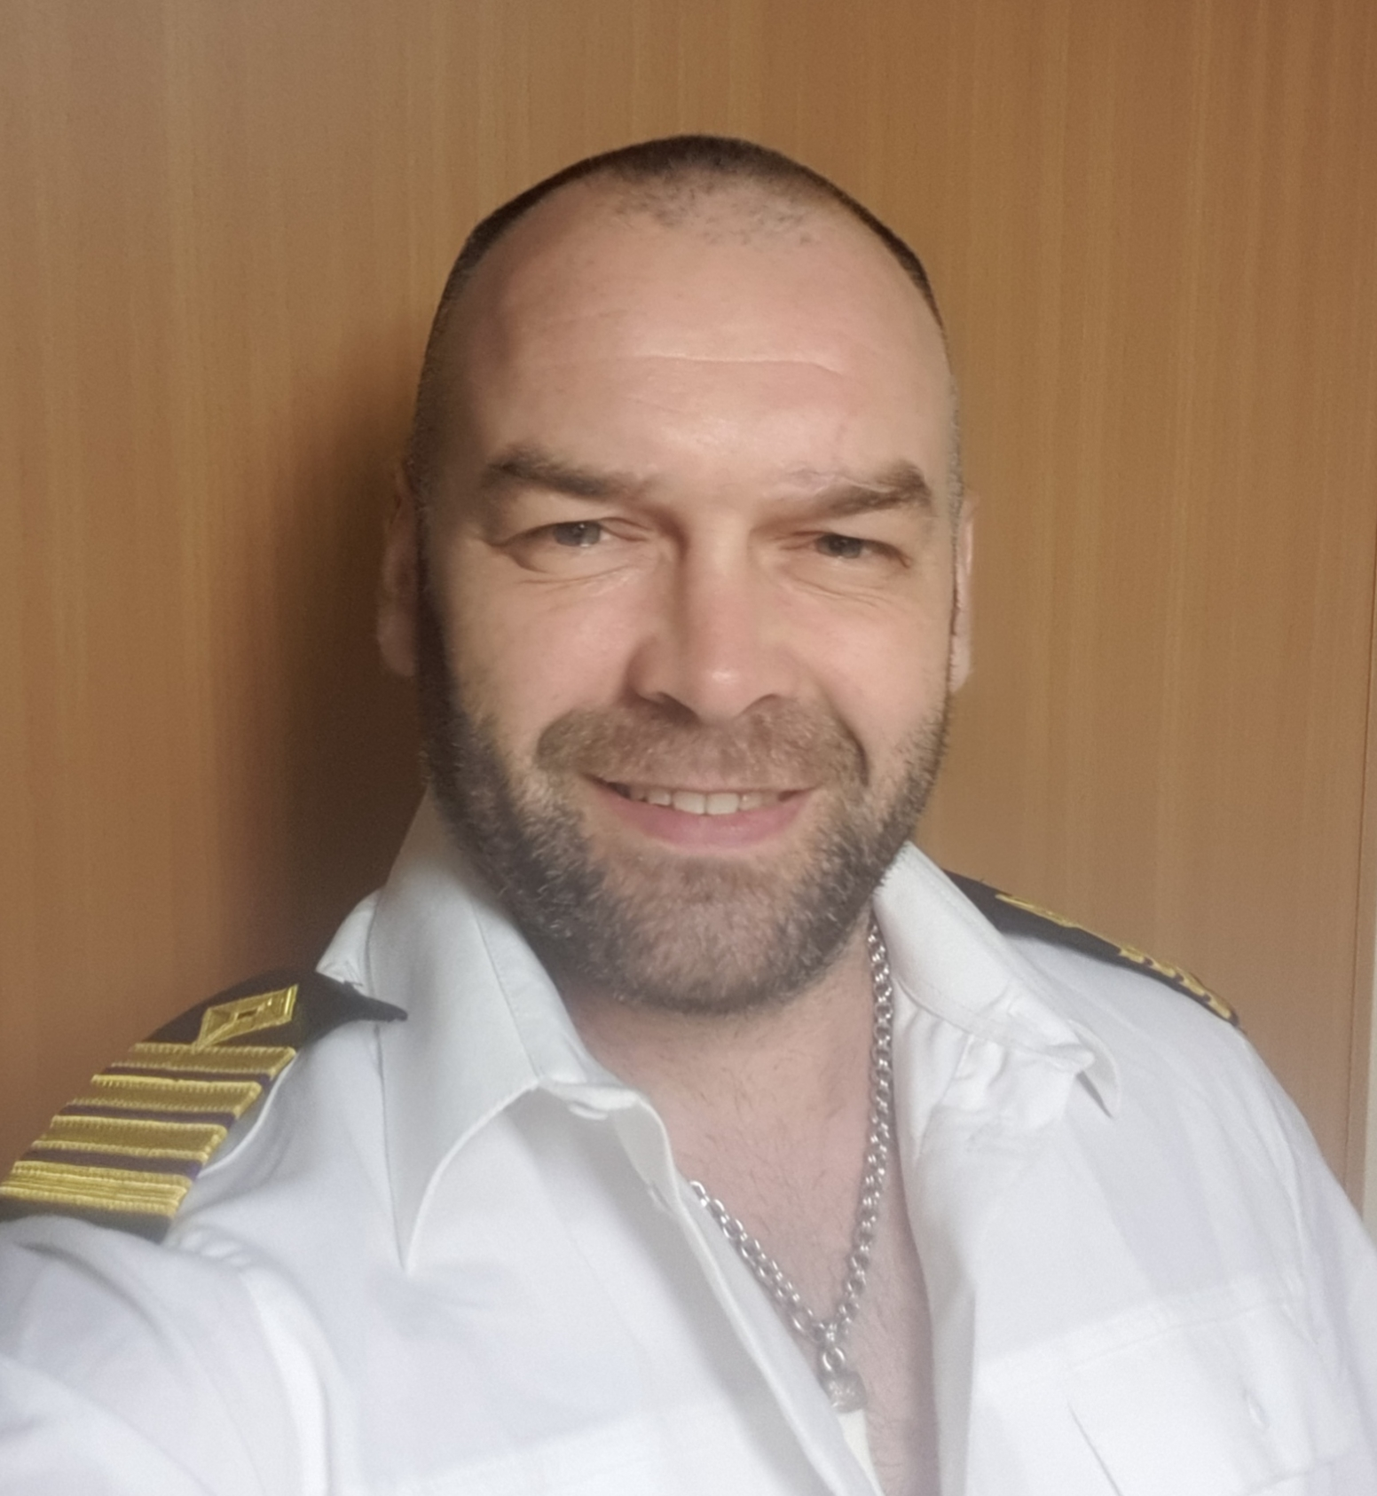
DATE/PLACE OF BIRTH: 10.03.1978 / USSR |  | NATIONALITY: Russian
INTERNATIONAL PASSPORT: |  | ISSUED/VALID: |  | 18.05.2020 |  | 18.05.2025
SEAMAN’S BOOK: |  | ISSUED/VALID: |  | 19.02.2012
SEAMAN’S ID CARD |  | ISSUED/VALID: |  | 29.11.2016 |  | 28.11.2021
SCHENGEN VISA: |  | ISSUED/VALID:
US VISA: |  | ISSUED/VALID: |  | 10.06.2019 |  | 06.06.2021
SKYPE ID: channel122 |  | MOBILE NO: +79143486015
E-mail:vladamyr@mail.ru |  | ENGLISH: GOOD x_ AVERAGE___ POOR___
STCW CERTIFICATES | REGULATION |  | NUMBER |  | ISSUED |  | VALID | PLACE OF ISSUE
CERTIFICATE OF COMPETENCY | Chief Engineer |  | LED 204682566 |  | 10.02.2021 |  | 12.01.2026 | Saint Petersburg
ENDORSEMENT
G.M.D.S.S. OPERATOR CERTIFICATE | A - IV / 2
G.M.D.S.S. OPERATOR ENDORSEMENT | A - IV / 2
BASIC SAFETY TRAINING | A – VI / 1 |  | 620-011/21-02C |  | 12.01.2021 |  | 12.01.2026 | Saint Petersburg
PROFICIENCY IN SURVIVAL CRAFT | A – VI / 2 |  | 622-13/21-02C |  | 13.01.2021 |  | 13.01.2026 | Saint Petersburg
ADVANCED FIRE FIGHTING | A – VI / 3 |  | 625-022/21-05C |  | 22.01.2021 |  | 22.01.2026 | Saint Petersburg
MEDICAL CARE ON BOARD | A – VI / 4
MEDICAL FIRST AID | A – VI / 4 |  | 628-018/21-08C |  | 20.01.2021 |  | 20.01.2026 | Saint Petersburg
A.R.P.A. | A – II / 1
Radar O&P | A – I / 12
TANKER FAMIRLIARIZATION | V / 1
OIL TANKERS SAFETY | V / 1
GAS TANKERS SAFETY | V / 1
CHEMICAL TANKERS SAFETY | V / 1
CRUDE OIL WASHING | MARPOL-73/78
INERT GAS SYSTEM | MARPOL-73/78
HAZARDOUS CARGOES | B-V/4&B-V/5
BRIDGE TEAM MANAGEMENT | 1.22
ERTM
ISM | A/1441 (18)
SHIP’S SAFETY OFFICER
SHIP’S SECURITY OFFICER
ECDIS
SHIP HANDLING ARRANGEMENTS | A-II/2
ELECTICAL & ELECTRONIC EQUIPMENT
SECURITY RELATIVE TRAINING | A-Vl/6-2 |  | 634-014/21-01C |  | 15.01.2021 |  | 15.01.2026 | Saint Petersburg
SEA SERVICE (last 5 years)
VESSEL NAME / IMO | VSL TYPE | DWT | YEAR | FLAG | ENGINE | BHP (Kwt) | COMPANY NAME | RANK | SERVICE DURATION
 |  |  |  |  |  |  |  |  | FROM | TO
Seamax New Haven/9293777 | Cont | 90449 | 2005 | MI | 12RTA 96C  68640 KW | 68640 | SAJSC | C/E | 17.07.2020 | 09.12.2020
Seamax New Haven/9293777 | Cont | 90449 | 2005 | MI | 12RTA 96C  68640 KW | 68640 | SAJSC | C/E | 17.10.2019 | 16.02.2020
ARGUELLO | Cont | 40839 | 2009 | Liberia | 8RTFlex82C | 36160 | BGI | C/E | 19.07.2019 | 29.08.2019
UASC UMM QASR | Cont | 94784 | 2014 | MI | SULZER W9X82 | 36440 | SAJSC | C/E | 09.06.2018 | 01.11.2018
UASC UMM QASR | Cont | 94784 | 2014 | MI | SULZER W9X82 | 36440 | SAJSC | C/E | 10.10.2017 | 22.02.2018
Al Bahia | Cont | 75579 | 2007 | Liberia | SULZER 11RTFLEX96C | 62920 | BGI | C/E | 16.03.2017 | 26.06.2017
Al Bahia | Cont | 75579 | 2007 | Liberia | SULZER 11RTFLEX96C | 62920 | BGI | 2/E | 05.12.2016 | 16.03.2017
Al Bahia | Cont | 75579 | 2007 | Liberia | SULZER 11RTFLEX96C | 62920 | BGI | 2/E | 05.04.2016 | 03.09.2016
Tacoma Trader | Cont | 8280 | 2015 | Singapore | MAN B&W 6S46ME-B8 | 10500 | BGI | 2/E | 05.08.2015 | 13.12.2015
OTHER PASSPORTS
MI PASSPORT: | MH 564423 | ISSUED / VALID: | 16.11.2017/ 15.11.2022
MI ENDORSEMENT: | 538437 | ISSUED / VALID: | 16.11.2017
PANAMA PASSPORT: |  | ISSUED / VALID:
PANAMA ENDORSEMENT: |  | ISSUED / VALID:
LIBERIAN PASSPORT: |  | ISSUED / VALID:
LIBERIAN ENDORSEMENT: |  | ISSUED / VALID:
CYPRUS PASSPORT: |  | ISSUED / VALID:
CYPRUS ENDORSEMENT: |  | ISSUED / VALID:

PERSONAL DATA

MARITAL STATUS: MARRIED____ SINGLE_____ DIVORCED____ WIDOWED__X___
WIFE’S NAME:
HOME ADDRESS: 9 Oblastnaya St. App. 377, Saint Petersburg, Russia
NEAREST AIRPORT: Pulkovo S. Petrburg |  |  |  |  | HOME PHONE NO:
NEXT OF KIN: |  | Kovtun Klavdia |  |  | CONTACT NO: |  |  | 89117988395
ADDRESS OF THE NEXT OF KIN: 2 Kirova st. App. 119 , Shlisselburg , Russia
FATHER’S NAME: |  | Victor Kovtun |  | MOTHER’S NAME: |  |  | Klavdia Kovtun
CHILDREN: SONS__ DAUGHTERS_X__ |  |  |  | NAMES OF CHILDREN: |  |  | Varvara Kovtun
HEIGHT: | 174 |  |  | WEIGHT:84
SHOES: | 41 |  |  | OVERALL SIZE: |  | 54
EYE COLOR: | Blue |  |  | HAIR COLOR: |  | Black
YELLOW FEVER: |  |  | 30.03.2016
MARLIN’S TEST: |  |  | 89 %

PRE-SEA EDUCATION
NAME OF SCHOOL OR ACADEMY | DEPARTMENT | FROM  (YEAR) | TO  (YEAR)
State Marine University | Engineer | 2006 | 2016
According to the Law of Russian Federation "On Personal Data Protection" from 27.07.2006, № 152-FZ, agrees LTD "Global Seaways Novorossiysk" to storage and the processing of my personal data in the filing of personal and / or using information and telecommunication system of the personal data of citizens of Russian Federation employed on ships of Foreign shipowner for the purpose of HR administration, training as required shipowners, administrative and other information on personnel.
I undertake when changing my personal data as soon as possible to provide the responsible person refined details and submit the originals of the relevant documents for entering my new personal data to the personal data of employees of the entity.

В соответствии с Законом Российской Федерации «О защите персональных данных» от 27.07.2006, № 152-ФЗ, даю согласие ООО “Глобал Сиуэйз Новороссийск ”на хранение и обработку моих личных персональных данных в картотеках и / или с помощью информационно-телекоммуникационной системы базы персональных данных граждан Российской Федерации, трудоустроенных на суда иностранных судовладельцев с целью ведения кадрового делопроизводства, подготовки в соответствии с требованиями судовладельцев, административной и иной информации по вопросам персонала.
Обязуюсь при изменении моих персональных данных предоставлять в кратчайшие сроки ответственному лицу уточненную информацию и подавать оригиналы соответствующих документов для внесения моих новых личных данных в базу персональных данных работников предприятия.

I HEREBY CERTIFY that the information above is true and correct. Any misrepresentation or misinformation on my part shall be grounds for the revocation of my
application and if already employed, shall be ground for termination without any responsibility / liability on the part of Global Seaways Novorossiysk whatsoever.
27.02.2021
_____________ _C/E Andrei Kovtun _ MK0104043 _________ Date of signing Rank Seafarer’s Name SB No. Signature

