CURRICULUM VITAE

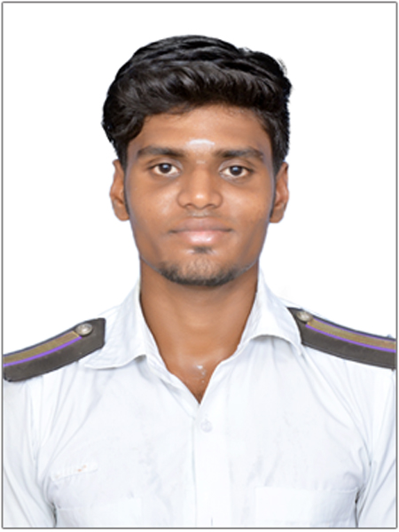
M.SELVAGANESHAN

12/17, SANGAIYA KOVIL STREET,
OLD KUYAVARPALYAM ROAD,
MADURAI CITY,
PIN- 625009,
TAMILNADU.
MOBILE : 8508052690
E-MAIL: selvaganenshan98@gmail.com
RANK APPLIED:TRAINEE MARINE ENGINEERING

OBJECTIVE:

A challenging technical position in marine engineering field , where my skills,
Attitude,education and accomplishments will contribute to the up lifement of your organization and myself.

EDUCATIONAL / PROFESSIONAL QUALIFICATION:

_{COURSE} | _{INSTITUTION} | _{BOARD&}  _{UNIVERSITY} | _{YEAR OF}  _{PASSING} | _{PERCENTAGE}  _{OF MARKS}
B.E Marine  Engineering | MOHAMMED SATHAK ENGINEERING COLLEGE. | Anna University  Chennai | 2019 | 72
HSC | TAGORE  VIDYALAYAM  MATRIC. HIGHER  SECONDARY  SCHOOL. | State Board | 2015 | 67.9
SSLC | TAGORE VIDYALAYAM MATRIC. HIGHER SECONDARY SCHOOL. | State Board | 2013 | 78.2

_{DOCUMENTS}

_{DOCUMENT} | _{DOCUMENT NO} | _{DATE OF ISSUE} | _{PLACE OF ISSUE} | _{VALIDITY}
PASSPORT | R7224734 | 03/01/2018 | MADURAI | 02/01/2028
CDC | MUM384368 | 20/06/2019 | MUMBAI | 19/06/2029
INDOS | 15EL2014 | 30/10/2015 | MUMBAI | LIFE TIME

_{TECHNICAL ACTIVITIES & STCW}

_{COURSES} | _{CERTIFICATE NO} | _{DATE OF ISSUE} | _{PLACE OF ISSUE} | _{INSTITUTE}
EFA | MF/BST/ 401007307190061 | 16/02/2019 | Chennai | Maritime Foundation
FPFF | MF/BST/ 401007307190061 | 16/02/2019 | Chennai | Maritime Foundation
PSSR | MF/BST/ 401007307190061 | 16/02/2019 | Chennai | Maritime Foundation
PST | MF/BST/ 401007307190061 | 16/02/2019 | Chennai | Maritime Foundation
STSDS | 40302114819378 | 01/06/2019 | Pondicherry | Pondicherry Maritime Acadamy
TFC | 40302107619185 | 25/05/2019 | Pondicherry | Pondicherry  Maritime Acadamy

_{PERSONAL DETAILS}

_{NAME} | _{M.SELVAGANESHAN}
_{AGE} | ₂₁
_{DATE OF BIRTH} | _{13.06.1998.}
_{SEX} | _{MALE.}
_{NATIONALITY} | _{INDIAN}
_{MARRITIAL STATUS} | _{UNMARRIED}
_{FATHER’S NAME} | _{K. MURUGAN}
_{MOTHER’S NAME} | _{M. AMBAL}
_{PERMANENT ADDRESS} | _{12/17, SANGAIYA KOVIL STREET,}  _{OLD KUYAVAR PALAYAM ROAD,}  _{MADURAI CITY,}  _{PIN - 625009}  _{TAMILNADU.}
_{CONTACT NUMBER} | ₈₅₀₈₀₅₂₆₉₀
_{EMAIL} | _{selvaganeshan98@gmail.com}

EXPERIENCE

Name of the vessel | Type of vessel | IMO No. | GRT | Rank | From | To | Kw
MV SEALION ACE | OFF SHORE | 9620906 | 471 | TME | 05/02/2020 | 12/10/2020 | 2*1838

PERSONAL SKIL

- Positive attitude worker,ability to work under pressure.
- Adjust quickly to the new environment.
- Equipped with good leadership abilities and good communication skills.
- A people’s person, capable of blending with the team.
- Committed to hard work and eager to learn and improve.
- Able to stay focused for a long time with right attitude.
- Adaptive to various situations.
- Developing innovative action plans to solve problems.

_{DECLARATION:}
I hereby declare that the above mentioned information is correct to my knowledge and I hear the responsibility for the correctness of the above mentioned particulars.

_{YOUR’S}

_{M.SELVAGANESHAN}

