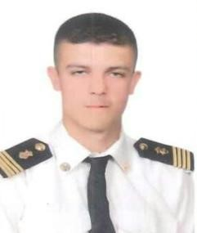
Lutfi Ahmad Al-Jalamneh
E-mail : lotfealjalamneh@hotmail.com
Date & place of Birth : Aug 24th, 1997
Amman - Jordan
Mobile: (+962) 791312515

PERSONAL SUMMARY

I’m looking for a job where I can excel my knowledge and skills to achieve company targets and goals, I believe in hard work and team work as well.

EDUCATION

- Academy (Jordan Academy for Maritime Studies).

- Certificates: 3rd engineer certificate

- Experience : one year experience (zakher marine international)
TRAINING COURCES:

- Advance firefighting.

- Personal survival technique.

- High voltage.

- Prevention and combating of marine pollution.

- Proficiency in survival crafts and rescue boat.

- Personal safety and social responsibility.

- Medical first aid.

- Shipboard familiarization.
- Proficiency of security awareness for seafarers with designated duties.

LANGUAGES
• Languages: Arabic: mother tounge
English –good.

