E
JOVAEL DEL ROSARIO

3RD OFFICER

DATE OF AVAILABILITY : 22 March 2021

OBJECTIVE

To be given the position of 3RD OFFICER where
I can utilize and contribute my technical skills.

To give my highest standard of discipline, professionalism, excellent
service, good moral character and performance management to your
company.

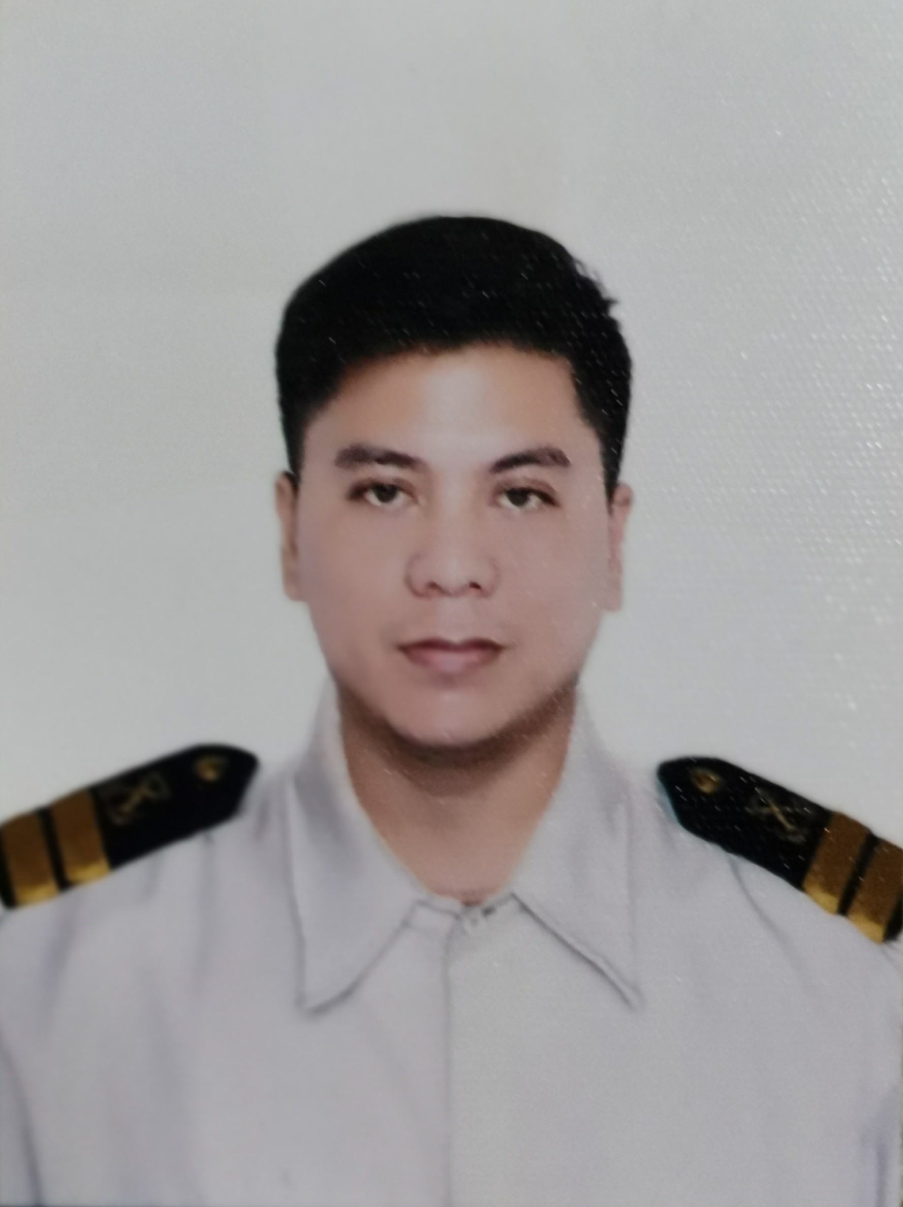

452 Buenavista, Magdalena, Laguna 4007
delrosariojovael25@gmail.comcom
+63917 140 7354

PERSONAL DETAILS

Full Name : Jovael del Rosario
Position Applied: Third Officer
Age: 37
Nationality: Filipino
Date of Birth: 25 May 1983
Permanent Address: 452 Buenavista, Magdalena, Laguna 4007
Current Address: 452 Buenavista, Magdalena, Laguna 4007
Civil Status: Married

Color of Hair: Black
Color of Eye: Brown
Foot Size: 42
Height(cm): 170
Weight(Kg): 76
Next of Kin(Relationship): Wife
Full Name: Reyma del Rosario
Gender: Female
Contact Number: 09176550370

EDUCTIONAL BACKGROUND

TYPE | NAME | FROM YEAR | TO YEAR | QUALIFICATION ATTAINED
College | PHILIPPINE MERCHANT MARINE SCHOOL LAS PIÑAS | 2001 | 2004 | BSMT
TRAVEL DOCUMENTS

 | NUMBER | DATE OF ISSUE | DATE VALID UNTIL | Place of Issue
Passport | P5676427B | 23-10-20 | 22-10-30 | DFA NCR SOUTH
Seaman’s book | C1350471 | 22-03-19 | 22-03-29 | BATANGAS
AUS MCV(E-ViSA) | NIL | DD-MM-YY | DD-MM-YY
US VISA C1/D | Expired | DD-MM-YY | DD-MM-YY

VACCINATIONS

NUMBER | TYPE | ISSUED | EXPIRES | PLACE OF ISSUE
 | YELLOW FEVER | 10-06-08 | UNLIMITED | MANILA

CERTIFICATES FOR OFFICERS

 | CAPACITY | NUMBER | NUMBER | EXPIRES | PLACE OF ISSUE
CERTIFACATE OF COMPETANCY | OFFICER IN CHARGE OF A NAVIGATIONAL WATCH | COICNW200002603421 | 21-01-21 | 21-01-26 | MARINA PITX
CERTIFICATE OF ENDORSEMENT | OFFICER IN CHARGE OF A NAVIGATIONAL WATCH | EOICNW200002595421 | 21-01-21 | 21-01-26 | MARINA PITX
GOC | GMDSS RADIO OPERATOR | GOC200004411621 | 21-01-21 | 21-01-26 | MARINA PITX

CERTIFICATES FOR RATINGS
 | CAPACITY | NUMBER | NUMBER | EXPIRES | PLACE OF ISSUE
 |  |  | DD-MM-YY | DD-MM-YY
 |  |  | DD-MM-YY | DD-MM-YY
 |  |  | DD-MM-YY | DD-MM-YY
 |  |  | DD-MM-YY | DD-MM-YY

TRAININGS CERTIIFICATES

 | CAPACITY | NUMBER | NUMBER | EXPIRES | PLACE OF ISSUE
Basic Training VI/1 | N/A | BT200036975921 | 05-03-21 | 05-02-26 | MANILA
Survival Craft & Rescue Boat VI/2 | N/A | PSCRB200022436821 | 05-03-21 | 02-02-26 | MANILA
Fast Rescue Boat and Training(VI/2) |  |  | DD-MM-YY | DD-MM-YY
Free Fall Life Boat Training (Fitted) |  |  | DD-MM-YY | DD-MM-YY
Advanced Fire-Fighting (VI/3) | N/A | AFF200012058821 | 05-03-21 | 05-02-26 | MANILA
Medical First Aid (VI/4) | N/A | 18-270745 | 07-11-16 | UNLIMITED | MARINA
Medical Care on Board (VI/4) | N/A | MECA200000038019 | 16-04-19 | UNLIMITED | MARINA
Designated Security Duty and Training(VI/6) | N/A | 27-297114 | 10-11-14 | NONE | MARINA
Bridge Team Resource Management (Simulator) | N/A | SSBT-150330AM | 04-09-15 | NONE | MANILA
Pacific Basin MRM Training - Swedish P&I Club |  |  | DD-MM-YY | DD-MM-YY
ECDIS (Generic IMO 1.27) 2010 Amendment | N/A | 2016-ECDIS-1349 | 30-09-16 | NONE | MANILA
ECDIS ( Type Specific) | N/A | 2018-01874 | 08-03-18 | NONE | JAPAN
Marpol Consilidated ( Annex 1-6) | N/A | MPOL/1007-335 | 30-07-10 | NONE | MANILA
Ship Handling & Maneuvering |  |  | DD-MM-YY | DD-MM-YY

SEA SERVICE

RANK | JOINED | SIGNED OFF | PERIOD | VESSEL | TYPE | ENGINE | GRT | KW | OWNER
3/O | 13 MAY 2019 | 25 JUL 2020 | 1Y 2M  12D | GANT FLAIR | BULK | B&W | 17, 018 T |  | SEATRANS MARINE LTD
3/O | 31 JAN 2018 | 24 NOV 2018 | 0Y 9M 24D | GANT FLAIR | BULK | B&W | 17, 018 T |  | SEATRANS MARINE LTD

EXPERIENCE BY VESSEL
VESSEL TYPE | PERIOD | NO. OF VOAYAGES
BULK | 6Y | 6
PASSENGER | 1Y | 1
CONTANER | 20M | 3
TOTAL |  | 9

EXPERIENCE BY RANK
RANK | PERIOD | NO. OF VOYAGES
3RD OFFICER | 2Y | 2
TOTAL | 2Y | 2

I hereby certify that the information given above are true and correct to the best of my knowledge and belief and that I have not withheld any information that would affect my application unfavorably.

Any false declaration I supplied herein may constitute ground for disqualification and non- acceptance to the company and can be further subjected to applicable penalties in accordance to existing laws governing the recruitment and employment of overseas seafarers.

JOVAEL DEL ROSARIO
Applicant

