CURRICULAM VITAE
POST APPLIED FOR : CHIEF COOK
NAME : VIRENDRA RAWAT
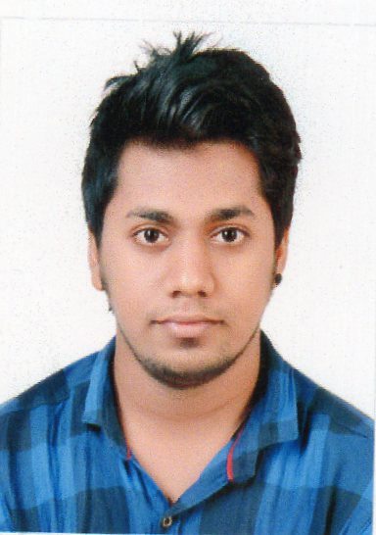
FATHER NAME : SUNDERSINGH RAWAT
GENDER / MARITAL STATUS : MALE, UNMARRIED
DATE OF BIRTH : 23 / 05 /1992
NATIONALITY / RELIGION : INDIAN / HINDU
LANGUAGES KNOWN : ENGLISH, HINDI
CONTACT NO : 8433609606 / 9324498234
QUALIFITION : 12TH PASSED
EMAIL : rawat.virendra1@gmail.com
PRESENT ADDRESS | PERMANENT ADDRESS
SURBI HS 1 UTKARSH RAHIVASI CHAWL NR AMBEDKAR MAIDAN AZAD NAGAR KOLSHET RD , THANE PIN : 400607 , MAHARASHTA , INDIA | SURBI HS 1 UTKARSH RAHIVASI CHAWL NR AMBEDKAR MAIDAN AZAD NAGAR KOLSHET RD , THANE PIN : 400607 , MAHARASHTA , INDIA
- DOCUMENT DETAILS
DOCUMENT | NUMBER | DATE OF ISSUE | DATE OF EXP | PLACE OF ISSUE
PASSPORT | N4699820 | 16/10/2015 | 15/10/2025 | THANE
INDOS | 15CL0390 | 24/03/2015 | UNLIMITED | MUMBAI
CDC(INDIAN) | MUM 254227 | 06/11/2015 | 05/11/2025 | MUMBAI
INDIAN COC | CC/MUM/2020/E004577 | 08/01/2020 | UNLIMITED | MUMBAI
OTFC / CTFC | YAK/OCTCO/12/003/14/16 | 10/12/2016 | UNLIMITED | MUMBAI
YELLOW FEVER | 19030 | 11/03/2019 | UNLIMITED | MUMBAI
- CERTIFICATE DETAILS
COURSE | CERTIFICATE NO. | DATE OF ISSUE | PLACE OF ISSUE
E.F.A. | BPMA/E/724/2015 | 23/04/2015 | MUMBAI
P.S.S.R. | BPMA/PSSR/1240/2015 | 24/04/2015 | MUMBAI
F.P.F.F | BPMA/FPFF/633/2015 | 27/04/2015 | MUMBAI
P.S.T. | BPMA/PST/385/2015 | 16/04/2015 | MUMBAI
P.S.R.S. | BPMA/PSRR/1240/2015 | 20/04/2015 | MUMBAI
AUGM | BPMA/AUGM/633/2015 | 23/04/2015 | MUMBAI
STSDSD | BPMA/STS/791/2015 | 23/04/2015 | MUMBAI
OTFC/ CTFC | YAK/OCTCO/12/003/14/16 | 10/12/2016 | MUMBAI
SHIP COOK COOKERY CERTIFICATE | BMFEMA/COOKERY/609/19/20 | 30/12/2019 | MUMBAI
STEWARD TRAINIG PROGRAM | AIMS/STP/04/32/2019 | 08/04/2019 | MUMBAI
BASIC H2S TRAINING | 00589014090619173572 | 09/06/2019 | ABU DHABI
BOSIET (OPITO APPROVED) | 00585700040619173416 | 2/06/2019 | ABU DHABI
- EXPERIENCE
- TWO SELLING ON PLAT FORM (HIRA / MNW /N97) AS A COOK.
NO | COMPANY NAME | SHIP NAME | GRT | FLAG | RANK | SING IN | SING OFF
1 | Udaya shipping | KUDETA 4305 | 2910 | PANAMA | COOK | 11.01.2019 | 13.01.2020
1 | Udaya shipping | M.V.VAHANA ARYAN | 5687 | SINGAPORE | COOK | 23.06.2019 | 16.12.2018
2 | AMS | DELMA11 | 1150 | UAE | COOK | 23.02.2018 | 25.12.2018
3 | AMS | DELMA11 | 1150 | UAE | COOK | 20.02.2017 | 23.02.2018
- DATE :
- PLACE: (VIRENDRA RAWAT)

