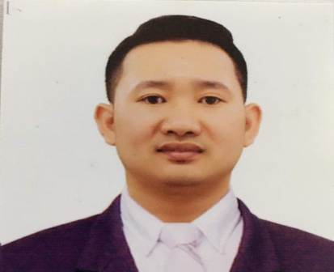
Zone 4, San Felipe
City of San Fernando, Pampanga, 2000
0915-7013-140
vitalraymart1993@gmail.com
Raymart gueco Vital
Objective |  | I am seeking a position where I can use my experience and education to help the company meet and surpass its goals.
Personal information  Training and seminars |  | BIRTH DATE: AUGUST 7, 1993  AGE: 27 YEARS OLD  WEIGHT: 163 LBS  HEIGHT: 5’7  GENDER: MALE  CIVIL STATUS: MARRIED  (COP) RATINGS, FORMING PARTS OF NAVIGATION WATCH  BASIC TRAINING WITH COP  SDSD WITH COP  PSCRB WITH COP
Experience |  | (2nd CONTRACT) Carnival plc.trading as p&o cruise Australia  PACIFIC EXPLORER- CRUISE VESSEL ( GROSS TONNAGE OF 77,441.00)  POSITION: GALLEY UTILITY  NOVEMBER 25, 2019 – JUNE 1 , 2020  (1st Contract) Carnival plc.trading as p&o cruise Australia  PACIFIC EXPLORER- CRUISE VESSEL ( GROSS TONNAGE OF 77,441.00)  POSITION: GALLEY UTILITY  FEBRUARY 21, 2019 – OCTOBER 07, 2019  HOKAIDO RAMEN SANTOUKA – KITCHEN STAFF  POSITION: SUSHI ROLL MAKER  NOVEMBER 16 , 2016 – NOVEMBER 30, 2018  ALA CRÈME (CAFÉ BISTRO CAKE SHOP) – COOK  POSITION: KITCHEN CREW  DECEMBER 9, 2015 – JUNE 9, 2016  M/V LADY OF LOVE–PASSENGER RORO VESSEL (GROSS TONNAGE OF 2,434.00)  POSITION: DECK CADET  JANUARY 18, 2014 – JANUARY 20, 2015
Education |  | “lci” lpu culinary institute  March 2018 – july 2018  Certificate in culinary arts with ncii  CEltech college - 2010 – 2014  CITY OF SAN FERNANDO, PAMPANGA  BACHELOR OF SCIENCE IN MARINE TRANSPORTATION
qualifications |  | - Responsible  - Trustworthy  - Adaptive  - Flexible
References |  | BRYANT DELA CRUZ  OIC – ALA CRÈME BISTRO CAFÉ  CELPHONE NO: 0927-8024-853

I hereby certify that above information is true and correct to the best of my knowledge and belief.

RAYMART G. VITAL

